jQuery Examples

**Accordion Example using jQuery**

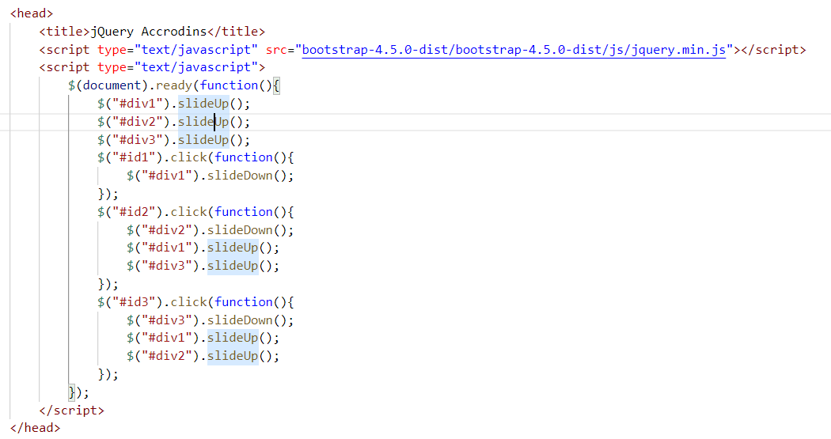

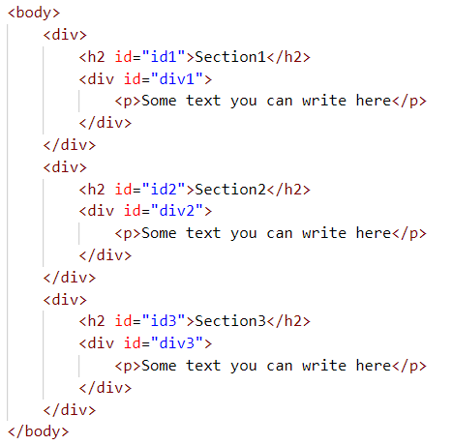

Accordion using jquery UI

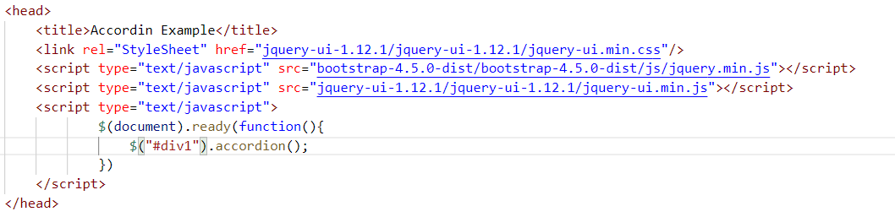

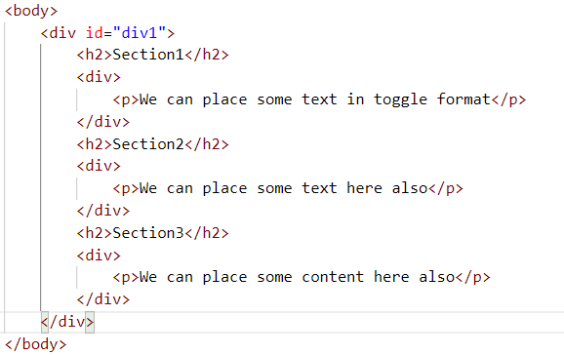

DatePicker using jquery UI

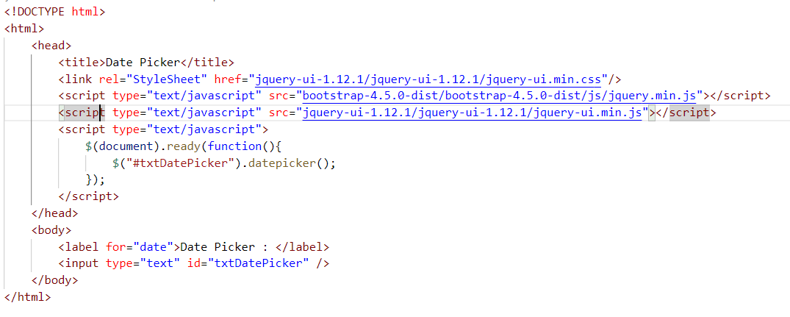

Tabs using jquery UI

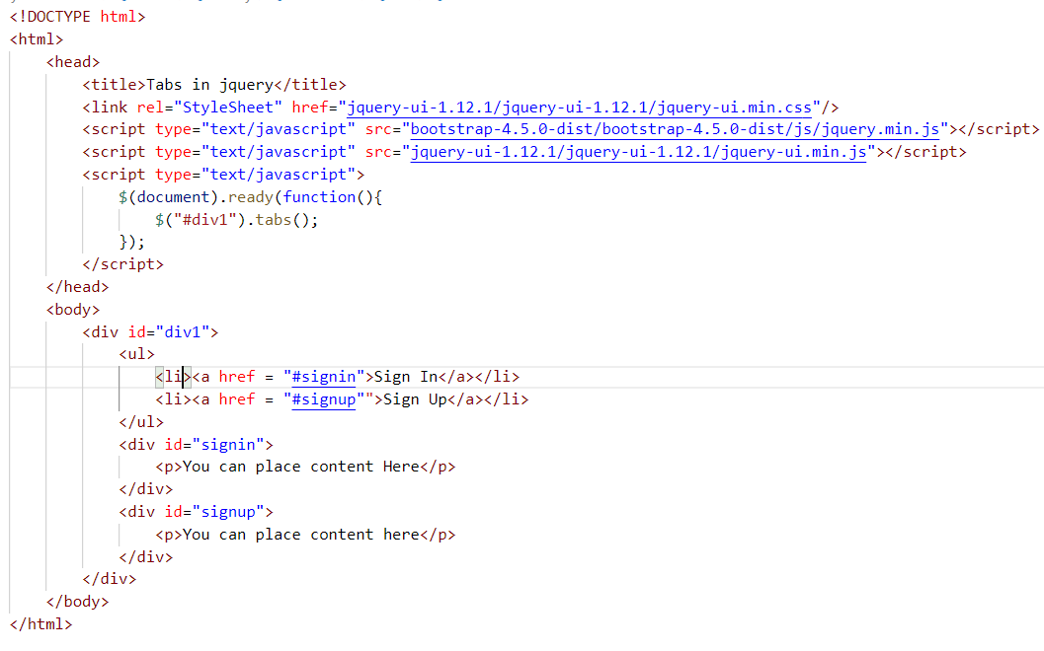

Task : Load the tabs in Modal Popup it means let’s take a button and clicks on the button it should need to show the popup with two tabs like Signin and Signup

**Solution**

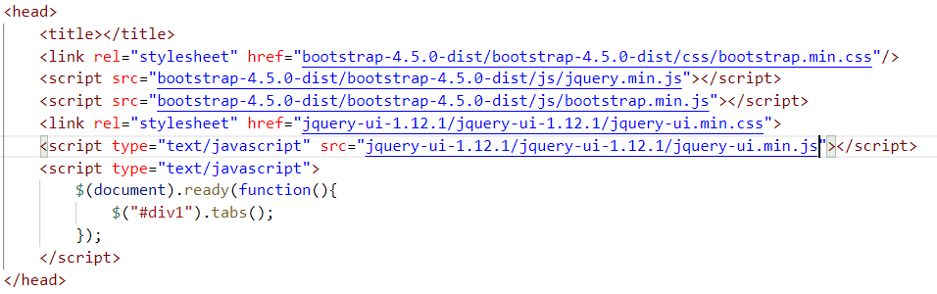

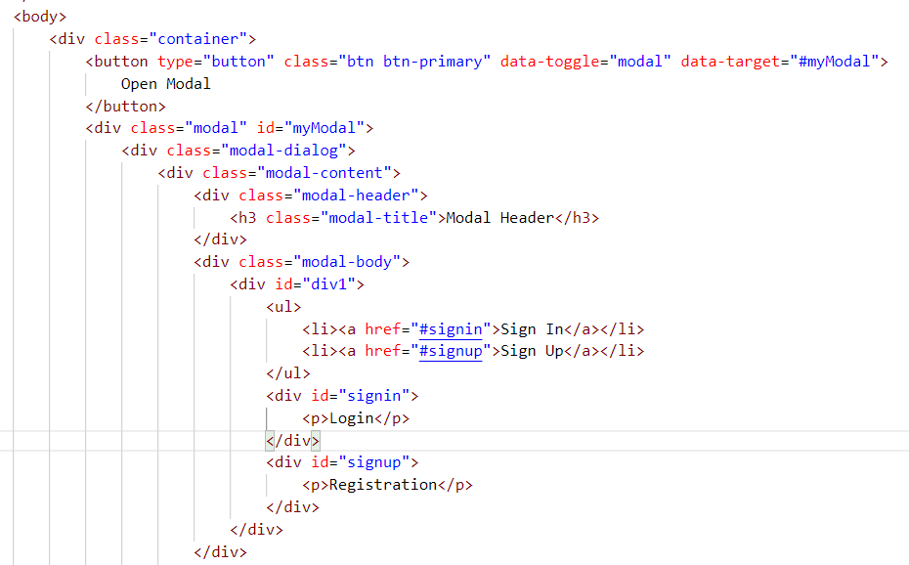

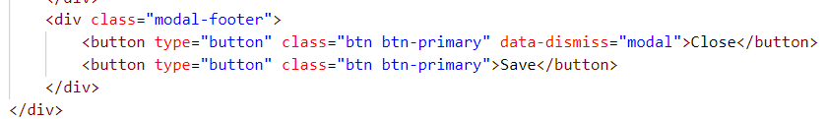

Animate using jquery

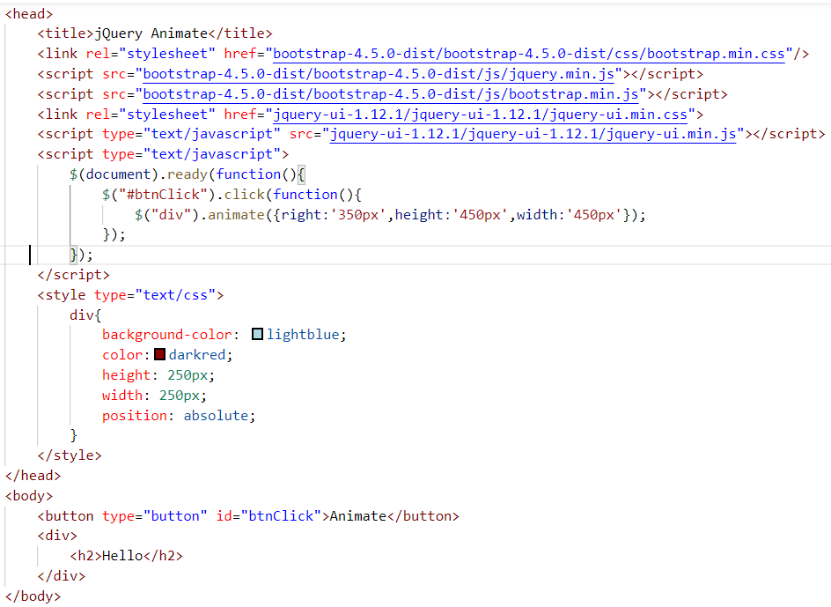

DOM - Document Object Model

DOM defines the structure of HTML document and XML documents

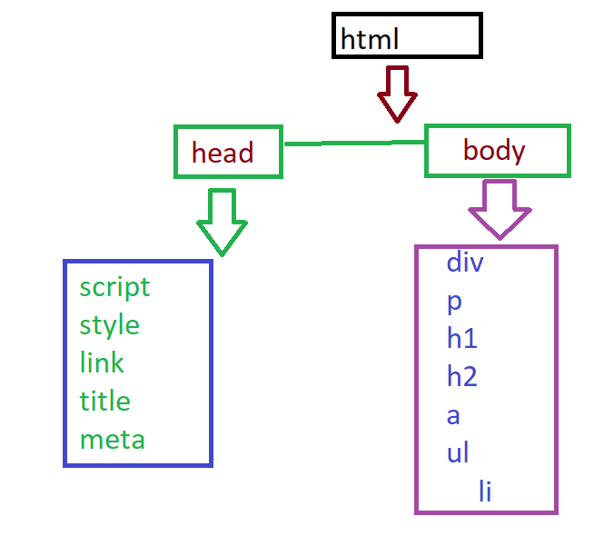

Reading the contents by using jQuery

To get the content will use text(), html() and val()

